**User Manual**

**Login to Manage System**

Users need to type in users' ID and password, and choose correct type of users i.e. student， teacher, administrator. We have a initial ID and password for three different types of the users to log in. You should choose the right user type, otherwise the system will send an error message to you. Be informed that different user-types aim to different user interface afterward.

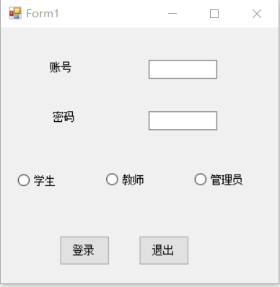

**Student Interface**

In student interface, there are four buttons to active different functions:

1) Enroll course;

2) query personal information;

3) query personal score;

4) query course enrollment info.

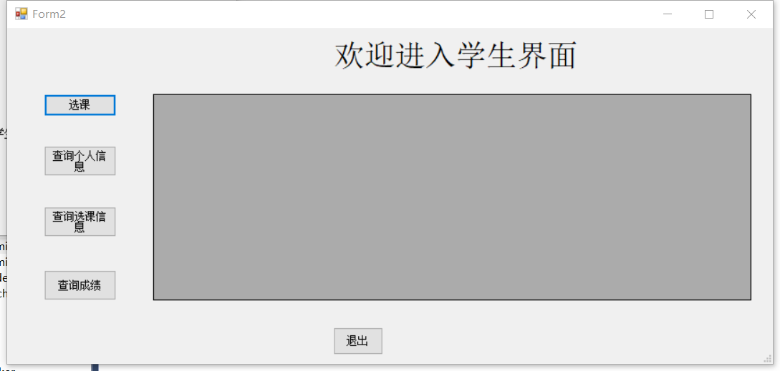  
When you click one of them, the datagridview will show the result. Especially, when you click the choose button, you will log in a new form to input the course ID information for choosing the course.

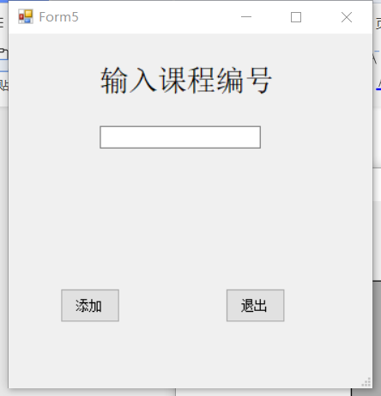

**Teacher Interface**

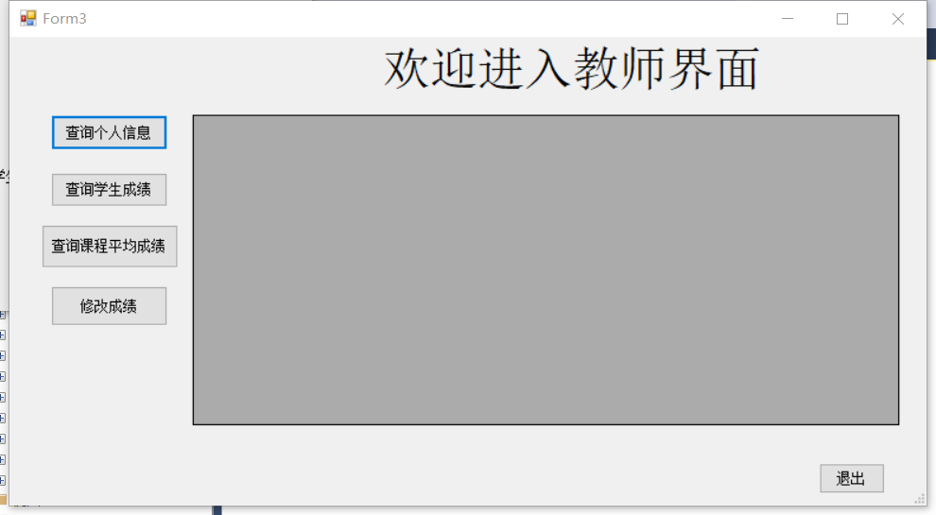There are a list of four button for:

1) Query personal information;

2) Query course score;

3) Query course average score;

4) Modify the score.

When you click one of them, the datagridview will show the result. Especially, when you click the modify button, you will log in a new form to input the student ID and the score you want to modify to change the score.

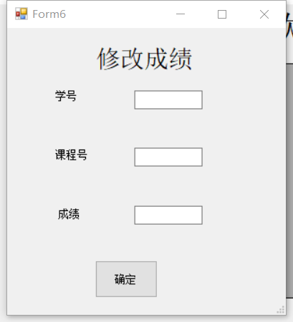

**Administrator Interface**

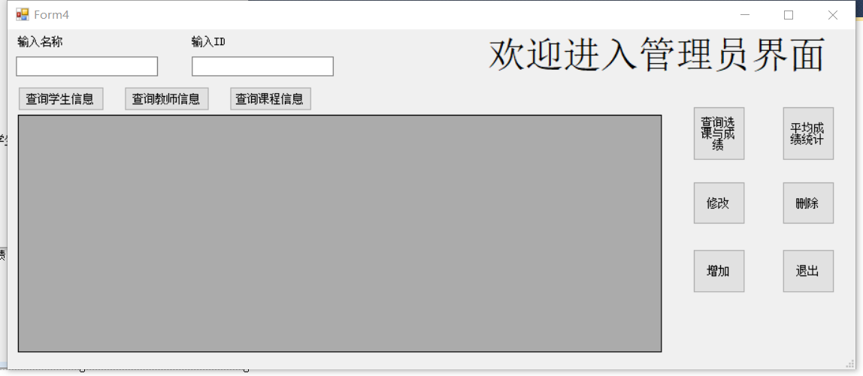In this interface, there are eight buttons to implement different functions:

1) Query student personal information;

2) Query teacher personal information;

3) Query course information;

For the first three functions, we support conditional querying, which uses the two textboxs to input ID and name to access information. All information will be shown if users don't input any id or name.

4) Query choose information;

As for choosing information, you will log in a new form to choose four types of the query method. You can use id or name for student, teacher, course to query the choose information. Another type is to query the score for the course.

5) Query average score information;

You will log in a new form to query the avg score, you can query course, student sum, student personal, class four types of the avg score by input the ID or name. For the sixth function, you will log in a new form to modify the all information of the database except the score.

1. modify;

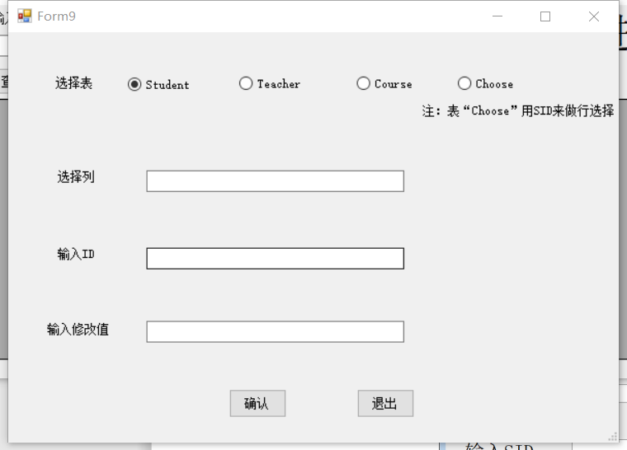

7) addition;

You will log in a new form to add student, teacher, course choice information.

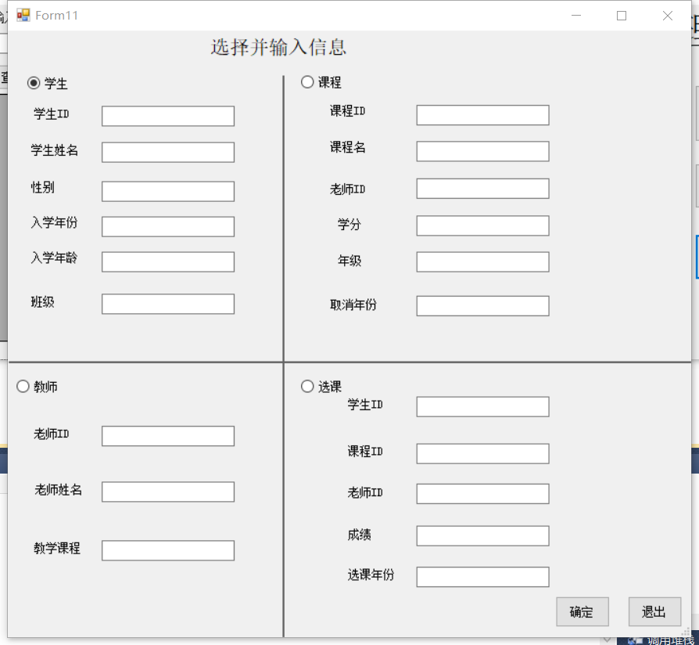

8) delete.

You will log a new form to delete student, teacher, choose by input the information.

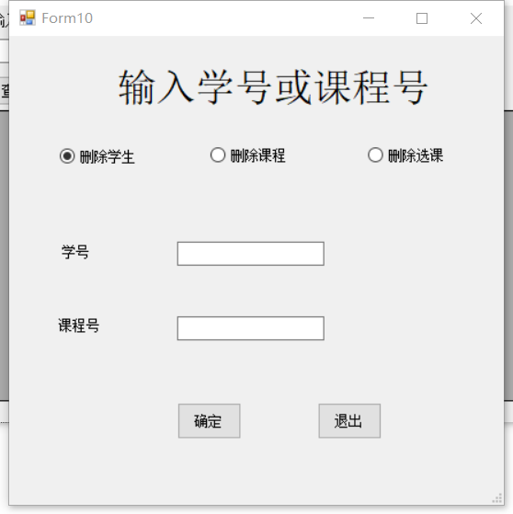

1. Test

We insert the follow information:

use MDB;

alter table choose NOCHECK constraint all;

alter table student NOCHECK constraint all;

alter table course NOCHECK constraint all;

alter table teacher NOCHECK constraint all;

alter table choose DISABLE trigger all;

alter table student DISABLE trigger all;

alter table course DISABLE trigger all;

alter table teacher DISABLE trigger all;

insert into Student values('1561401613',N'毛挺','男','18','2015',N'计联');

insert into Student values('1530561331',N'谈力','男','18','2015',N'计联');

insert into Student values('1530501085',N'晁阳','男','19','2015',N'计联');

insert into Student values('1530591376',N'韩梅梅','女','17','2015',N'计科');

insert into Course values('1008060',N'算法','10001',2,'2','2019');

insert into Course values('1203006',N'计组','10003',1,'2','2018');

insert into Course values('3009405',N'java','20010',2,'1','2020');

insert into Course values('7787564',N'经济学','35790',1,'1','2020');

insert into Teacher values('10001',N'颜老师',N'算法');

insert into Teacher values('10003',N'毛老师',N'计组');

insert into Teacher values('20010',N'张老师',N'java');

insert into Teacher values('35790',N'田老师',N'经济学');

insert into Choose values('1561401613','1008060','10001',95,null);

insert into Choose values('1561401613','1203006','10003',92,null);

insert into Choose values('1561401613','3009405','20010',94,null);

insert into Choose values('1530561331','1008060','10001',96,null);

insert into Choose values('1530561331','1203006','10003',88,null);

insert into Choose values('1530591376','1203006','10003',94,null);

insert into Choose values('1530591376','3009405','20010',92,null);

insert into Permission1 values('1561401613','111111');

insert into Permission1 values('1530561331','222222');

insert into Permission1 values('1530501085','333333');

insert into Permission1 values('1530591376','444444');

insert into Permission2 values('10001','555555');

insert into Permission2 values('10003','666666');

insert into Permission2 values('30405','777777');

insert into Permission2 values('35790','888888');

insert into Permission3 values('24680','100000');

select * from choose;

select * from Student;

select * from Teacher;

select * from Course;

select * from Permission1;

select * from Permission2;

select * from Permission3;